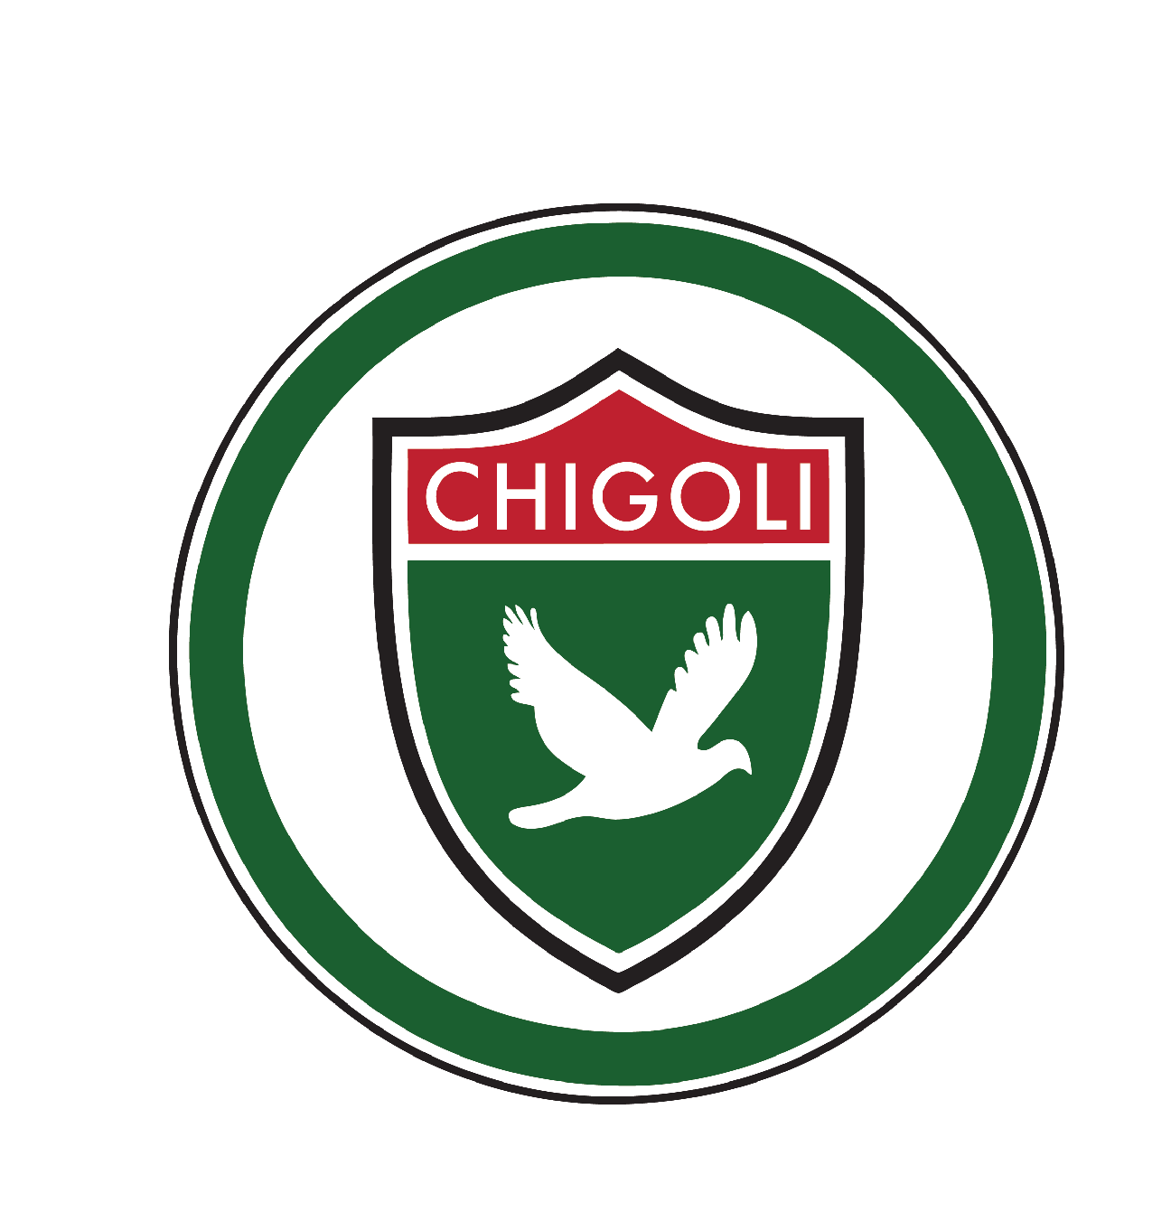

Chigoli Child Protection Policy

Chigoli fully recognises its responsibilities for child protection.
Our policy applies to all staff, governors and volunteers working in the organisation. There are five main elements to our policy:
- Ensuring we practice safe recruitment in checking the suitability of staff and volunteers to work with children.
- Raising awareness of child protection issues and equipping children with the skills needed to keep them safe.
- Developing and then implementing procedures for identifying and reporting cases, or suspected cases, of abuse.
- Supporting pupils who have been abused in accordance with his/her agreed child protection plan.
- Establishing a safe environment in which children can learn and develop.

We recognise that because of the day to day contact with children, staff are well placed to observe the outward signs of abuse. Chigoli will therefore:
- Establish and maintain an environment where children feel secure, are encouraged to talk, and are listened to.
- Ensure children know that there are adults in the school whom they can approach if they are worried.
- Include opportunities in the Character Development curriculum for children to develop the skills they need to recognise and stay safe from abuse.

Chigoli shall:
- Ensure we have a nominated person responsible for child protection.
- Ensure every member of staff (including temporary and supply staff and volunteers) and governing body knows the name of the designated senior person responsible for child protection and their role.
- Ensure all staff and volunteers understand their responsibilities in being alert to the signs of abuse and responsibility for referring any concerns to the designated senior person responsible for child protection.
- Ensure that parents have an understanding of the responsibility placed on the Chigoli staff for child protection by setting out its obligations in the school prospectus.
- Develop effective links with relevant agencies and co-operate as required with their enquiries regarding child protection matters including attendance at case conferences.
- Keep written records of concerns about children, even where there is no need to refer the matter immediately.
- Ensure all records are kept securely.
- Follow procedures where an allegation is made against a member of staff or volunteer.
- Ensure safe recruitment practices are always followed.

We recognise that children who are abused or witness violence may find it difficult to develop a sense of self worth. They may feel helplessness, humiliation and some sense of blame. The school may be the only stable, secure and predictable element in the lives of children at risk. When at Chigoli their behaviour may be challenging and defiant or they may be withdrawn. Chigoli will endeavour to support the pupil through:
- The content of the Character Development curriculum.
- The Academy ethos which promotes a positive, supportive and secure environment and gives pupils a sense of being valued.
- The Academy player code of conduct which is aimed at supporting vulnerable pupils in the school. The Academy will ensure that the player knows that some behaviour is unacceptable but they are valued and not to be blamed for any abuse which has occurred.
- Liaison with other agencies that support the pupil such as social services.

